Date | 28 September 2026
Team ID | SWTID-2026-7034
Project Name | API FAQ ASSISTANT
Maximum Marks | 4 Marks
Technical Architecture:
The deliverable includes the architectural diagram below and the information as per Table-1 and Table-2.
Architecture: API FAQ Assistant
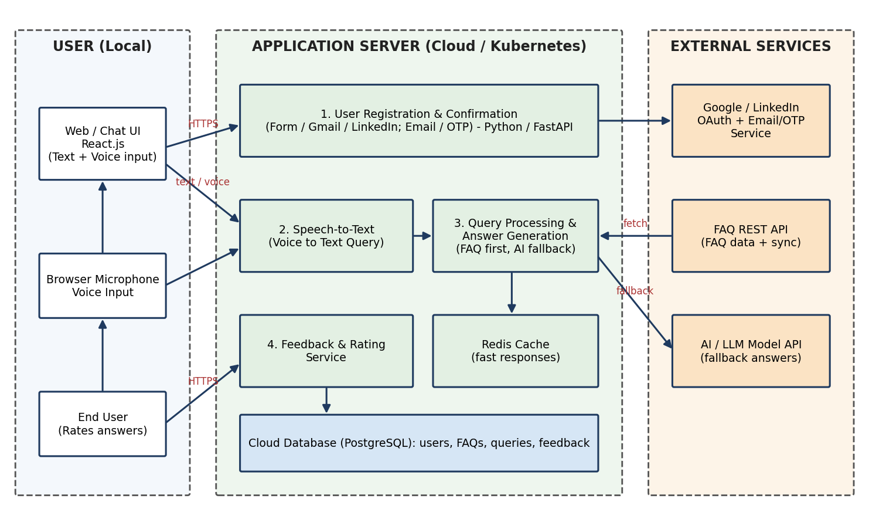
Table-1 : Components & Technologies:
S.No | Component | Description | Technology
1 | User Interface | Chat interface where users register, ask questions by text or voice, view answers and rate them. | HTML, CSS, JavaScript, React.js
2 | Application Logic-1 | User registration (Form, Gmail, LinkedIn) and confirmation via Email / OTP; FAQ search and answer generation logic. | Python (FastAPI / Flask)
3 | Application Logic-2 | Converts voice queries to text for FAQ search. | Speech-to-Text service (Web Speech API / Google STT)
4 | Application Logic-3 | Generates answers from the FAQ database; falls back to an AI model when no FAQ match is found. | Python, LLM API integration
5 | Database | Stores user profiles, FAQ entries, queries, feedback and ratings. | PostgreSQL / MySQL
6 | Cloud Database | Managed database service on cloud with backups and replication. | AWS RDS / Cloud SQL / MongoDB Atlas
7 | File Storage | Stores logs, cached FAQ snapshots and static assets. | Cloud object storage (e.g. AWS S3) or local filesystem
8 | External API-1 | Fetches FAQ data via REST API and syncs updates automatically, with error handling. | FAQ REST API (JSON over HTTPS)
9 | External API-2 | Third-party sign-in (Google, LinkedIn OAuth) and email / OTP delivery for confirmation. | Google OAuth 2.0, LinkedIn OAuth, SendGrid / Twilio
10 | Machine Learning Model | AI fallback for answering questions not covered by the FAQ database; semantic matching of queries. | Large Language Model API (e.g. Claude API)
11 | Infrastructure (Server / Cloud) | Application deployed in containers on a cloud server behind a load balancer. Local: development on localhost. Cloud: containerised services with autoscaling. | Docker, Kubernetes, Cloud (AWS / GCP / Azure), Nginx
Table-2: Application Characteristics:
S.No | Characteristics | Description | Technology
1 | Open-Source Frameworks | Open-source frameworks used to build the front end, back end, caching and deployment. | React.js, FastAPI / Flask, PostgreSQL, Redis, Docker, Kubernetes
2 | Security Implementations | HTTPS/TLS for all API traffic; password hashing; encrypted API keys and user data; token-based access control; OTP verification; firewall and OWASP practices. | TLS, SHA-256 / bcrypt, AES encryption, JWT, OAuth 2.0, IAM controls, WAF / firewall, OWASP Top 10
3 | Scalable Architecture | 3-tier architecture (UI, application, database) with stateless services that scale horizontally to support more concurrent users and API requests. | React.js, FastAPI microservices, Kubernetes autoscaling
4 | Availability | Load balancers and multiple service replicas, database replication and automatic restart of failed containers to target 99.9% uptime. | Nginx / Cloud Load Balancer, Kubernetes replicas, managed DB replication
5 | Performance | Responses within 2-3 seconds under normal load through caching of frequent FAQ answers, database indexing, asynchronous API calls and a CDN for static files. | Redis cache, DB indexes, async Python, CDN

